LOCATION : NATIONWIDE
DATE : 22.12.2017
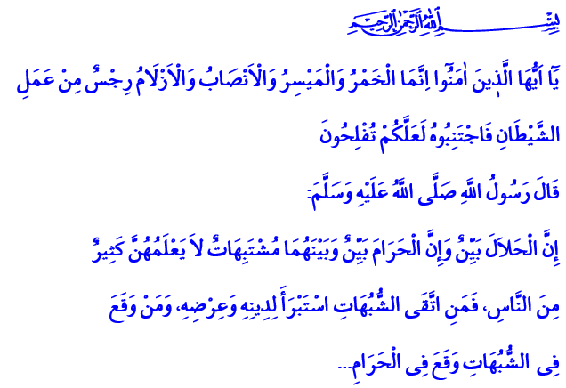
SENSITIVITY TO HALAL AND HARAM
Blessed Friday to You, Honorable Believers!
Our Lord Almighty enjoins in the verse I have recited: “O you who believe! Intoxicants (all kinds of alcoholic drinks), gambling, Al-Ansab, and Al-Azlam (arrows for seeking luck or decision) are an abomination of Shaitan's (Satan) handiwork. So avoid (strictly all) that (abomination) in order that you may be successful.”
Our Prophet (pbuh) said in the holy hadith I have read: “What is lawful is evident and what is unlawful is evident, and in between them are the things doubtful which many people do not know. So he who guards against doubtful things keeps his religion and honor blameless, and he who indulges in doubtful things indulges in fact in unlawful things…”
Brothers and Sisters!
Our Lord Almighty created mankind as the most honorable of all creation. He set some boundaries for mankind to protect his pure nature and ensure his eternal salvation. We call these boundaries that we should obey throughout our lives halal and haram.
Halal are the beautiful things that are in accordance with the reason and purpose of creation. Haram are the ugly things that harm and hurt the honor and dignity of the mankind, the respected creation of our Lord. Halal are the words, behaviors and attitudes in accordance with Allah countenance. Haram are the evil things that would bring upon our Lord’s wrath and people’s condemnation.
Dear Believers!
To pay regard to halal indicates our faith towards Allah, in other words our loyalty towards the oath of servitude we gave to Him. To get involved in haram is to ignore that oath. Seeking halal is an effort towards living a decent, upright, and honorable life. Indulging in haram is a state where the mind and heart is clouded, where a person is a slave to the vain desires and wants.
The closer a person is to halal, the closer he is to peace. Walking towards haram ends in regret and misery.
The result of a life wasted by losing the sensitivity to halal-haram is disappointment.
Dear Brothers and Sisters!
In our religion, nobody has the authority to define halal and haram according to their wishes. Every believer who believes in the merciful messages of the Holy Quran and walks on the noble path of our Prophet (pbuh) must be sensitive to halal-haram. A believer, by requirement of faith, is a person who loves his Lord, knows his boundaries and knows himself. He cannot lose his conscience and mercy and hurt any creature. He cannot hurt the dignity of himself and others by acting insensitive, disrespectful and unvirtuous.
A believer cannot waste his limited breaths in this transitory world on unfair gains such as fortune-telling, gambling, luck games, interest, bribe, usury, and theft. He cannot poison the body Allah entrusted to him with alcohol and drugs. He cannot harm his health with non-halal foods and drinks.
A believer is such a person that he cannot touch the property of an orphan. He cannot be unjust towards the rights of another person or the public. He cannot treat his wife and children, his parents, neighbors and relatives badly. He cannot stain his tongue with bad words, slander, lies and perjury. He can never betray someone’s trust and break his promise. He cannot pursue sedition and malice and spread corruption on earth.
Esteemed Brothers and Sisters!
As believers, let us look at our attitude towards the boundaries of halal and haram. Let each of us ask ourselves these questions: Do we live a life within the scope of halal-haram sensitivity? Or are we in a situation where our perception is paralyzed? Do we put our happiness in this world and hereafter in danger by not caring about sins and not avoiding haram? Or are we able to leave our faults back never to return with a sincere repentance?
Dear Brothers and Sisters!
Let us not forget, what is fitting for a believer is to be aware against halal and haram. People could make mistakes. But the most sagacious of those who make mistakes are the ones who turn back from these faults and repent.
I want to conclude this khutba with this prayer of our Prophet (pbuh): “O Allah! Set me apart from my sins as the East and West are set apart from each other and clean me from sins as a white garment is cleaned of dirt!”

Al-Maidah, 5/90.
Al-Bukhari, Book of Faith, 39; Sahih Muslim, The Book of Musaqa, 107.
Al-Bukhari, Book of Call to Prayers, 89. Written by: General Directorate of Religious Services

